The class ended so from here on out I must go rouge!

Today, 5/2/2024, I focused on making the program usable from a user’s perspective.

Let’s face it unless you’re a super genius its essentially not possible to go create a minterm function without first having a truth table to look at! Well, that is what I solve with this version.

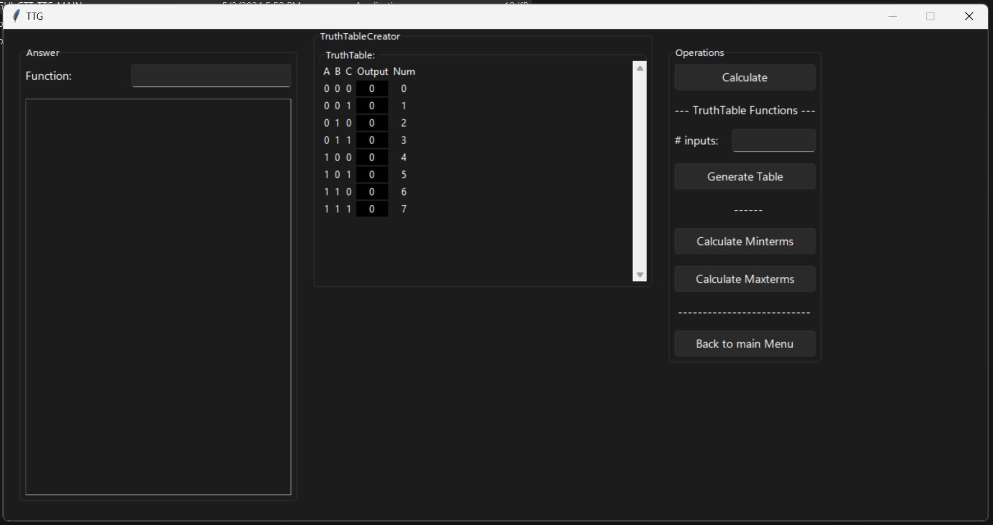

In the middle is the truth table section, on the right is the controls, and on the left is the output.

To interface with the truth table you just have to click on the output num you want to change and it will flip between 0 and 1. If you want a bigger or smaller truth table, just enter the number into the #inputs box and click generate table button.

The Maxterms button doesn’t work yet because of code in the back end, but the minterms button works great here is an example:

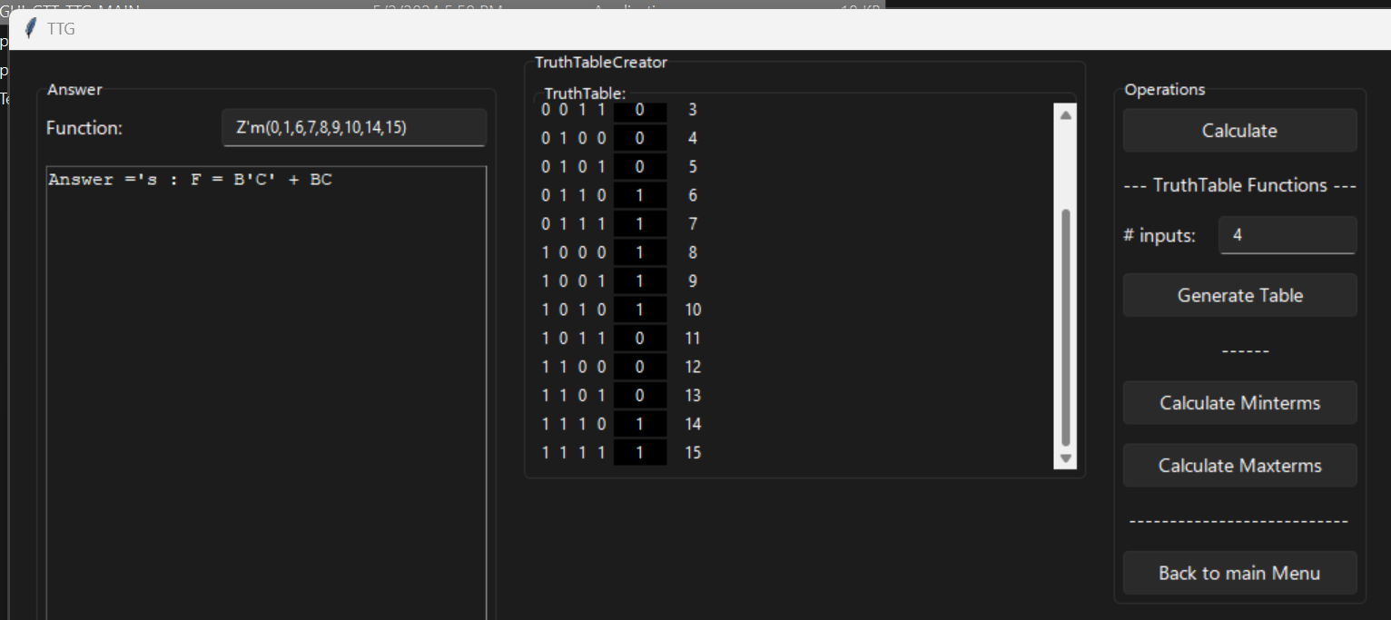

As you can see I expanded the Truth Table and generated an answer.

Think Aloud 7

Disclaimer, you should probably look into reading my older think aloud’s at the end of the document before reading the newest one 😉.

Because this if the final week I decided that I would take my program is it is, even though there are many things wrong with It, and package it up into a little GUI. Here are all the menus:

Main menu:

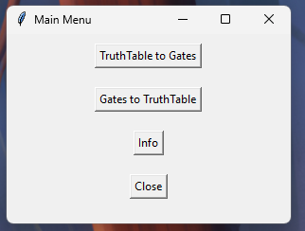

Truth Table to Gates:

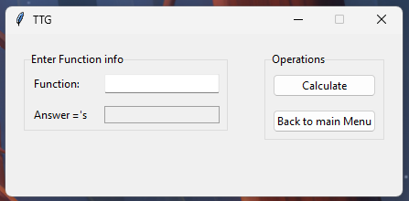

Gates to Truth Table:

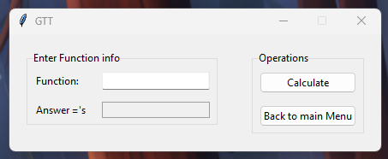

Info:

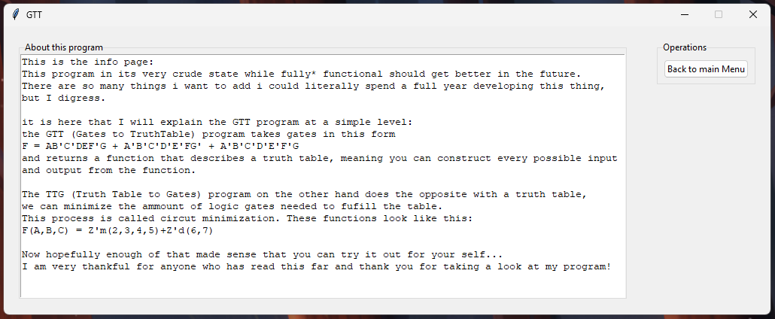

I want to note that this program as it is does not look the way I want it to end the end. Here are some ideas I have to drastically improve this GUI program.

1. Make the TTG have an interactable Truth table that I can resize and edit as I want so that I can see exactly what I am doing.
2. Make the GTT have a interactable Truth table that I can look though and skim for mistakes or for fun.
3. At least make it possible to obtain all of the functionality from the original CLI programs, because right now the only thing you get is the answer. This additional information could be in a TOAST or some another pane, but I want more context than just the answers from these programs.
4. I want the Info page to actually go into how this works, so that anyone just finding the program could possibly understand it without any exterior knowledge.
5. …

And so on, I could continue listing features I wanted to add forever but at this poing im just glad I got a baseline functional program up and running.

Thanks for reading up to this point.

Additionally I want to add that last week I spent the entire time trying to learn how to implement this but in a game engine.

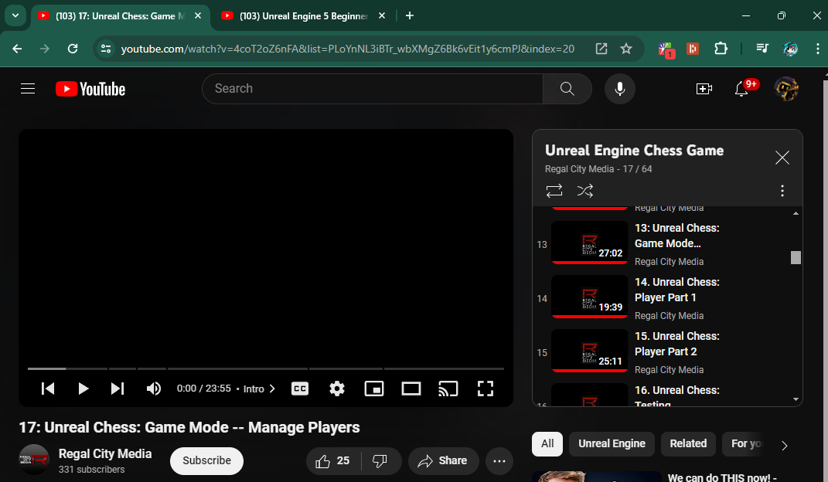

To give you some insight on what I am imagine I will explain it here.

I want an application that has a interactive GUI. I want to be able to make chips, calculate Truth Tables, Minimize circuits, play with Gates… because from the very beginning almost a year ago now this is what the point of this project if for. I want to make a real “Logic Simulator” that would be fun so anyone could learn how logic works. I wanted to at least break ground on it this week (hence the reason last week was spent by me learning unreal engine), but then I realized that this was the last week and I wouldn’t have anywhere near enough time to get working on a functional product to show at the end.

Anyway if I manage to make this in the future I will be so happy because it has been my dream for a long time now. There just are not any real logic simulators made for ordinary people to play with. The closest one is [Sebastian Lague's](https://www.youtube.com/@SebastianLague) “[LogicSim](https://sebastian.itch.io/digital-logic-sim)” that uses Unity engine as the back end, my only issue with it is that it does not include ways to generate truth tables, or minimize circuits or ways to expand beyond the frame of the window your given at the start.

Well anyway Thank you guys for Reading but I know for a fact nobody cares about this anyway… ☹ welp if you are reading this and do care I am so thankful I can share my enthusiasm with you Maby you would want to get in touch with me at some point so here is my email [aidan.t.newberry@gmail.com](mailto:aidan.t.newberry@gmail.com). I hope so bad that someday I will get this project to a place that I am satisfied with. Thanks for reading!

Think Aloud 6

Disclaimer, You should probably look into reading my older think aloud’s at the end of the document before reading the newest one 😉.

This week I made a few discoveries and some big progress, The first and most major thing would be the completion of my gates to truth table program in python. Every major feature I wanted to add has been added and the biggest difference from last week is the SQL table output. Here is a few test cases being successfully ran:

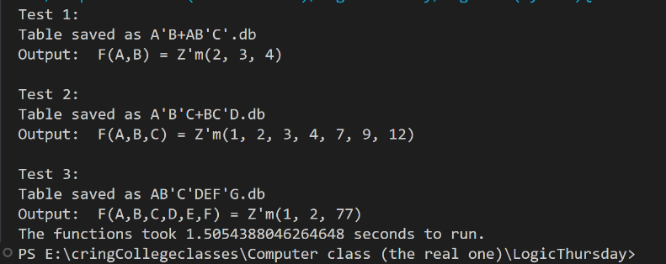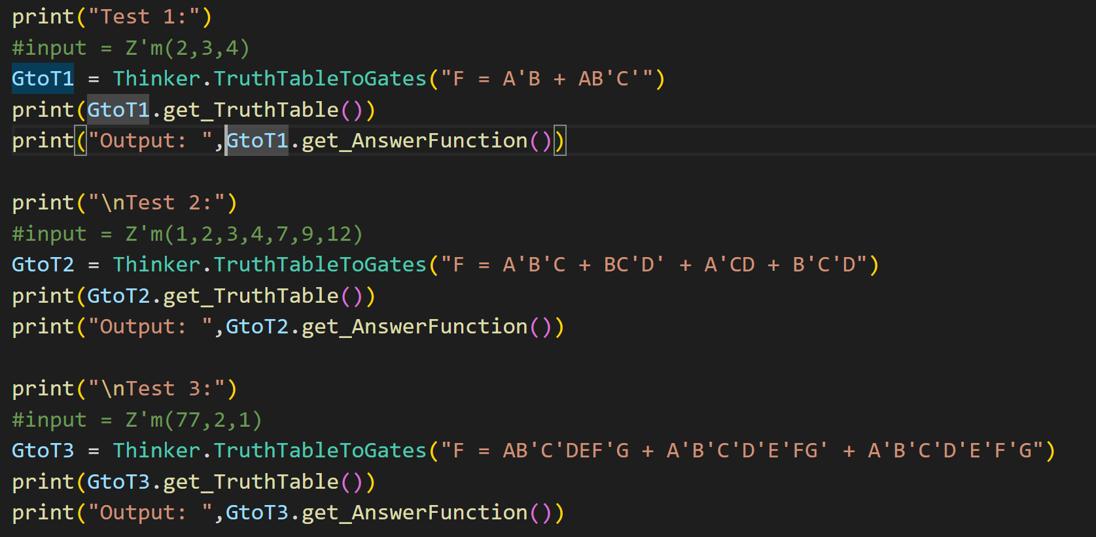

As you can see it runs nice and efficently. The worst part of this program is writing the table to the drive. For longer functions it has to write many MANY thousands of lines to the drive. I havent looked into it seriously yet but because of this serious oversight it can take a few days to write some of these truthtables to a SQL table. Here is the biggest table the program supports writing, but it literally took my server 4 days of solid work to calculate it:

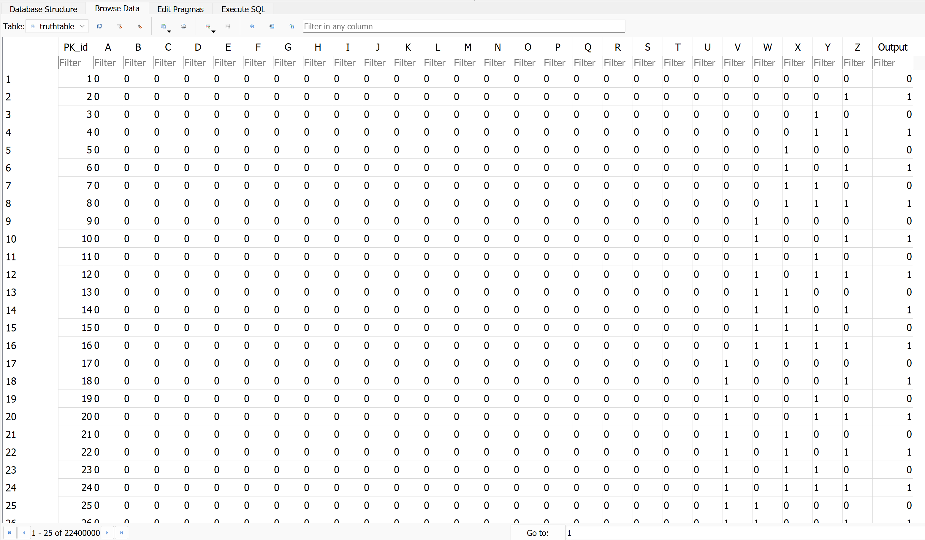

This table has 22,400,000 different combinations, so you can see why it too so long to write to the drive line by line. I hope to make this process faster in the future. In other news I took a field trip to Iowa and on the way I directly translated the this program’s init function to CPP hoping to make the calculations faster. Only issue is it didn’t make it faster the python version is actually 45% faster than the CPP version. I really didn’t expect this to be the case, but for this reason I made a time tester version of the program here are the results:

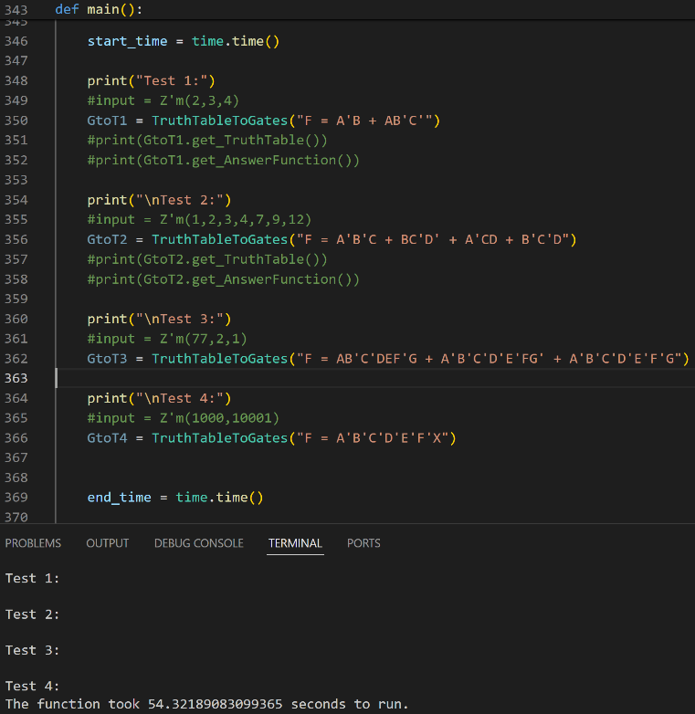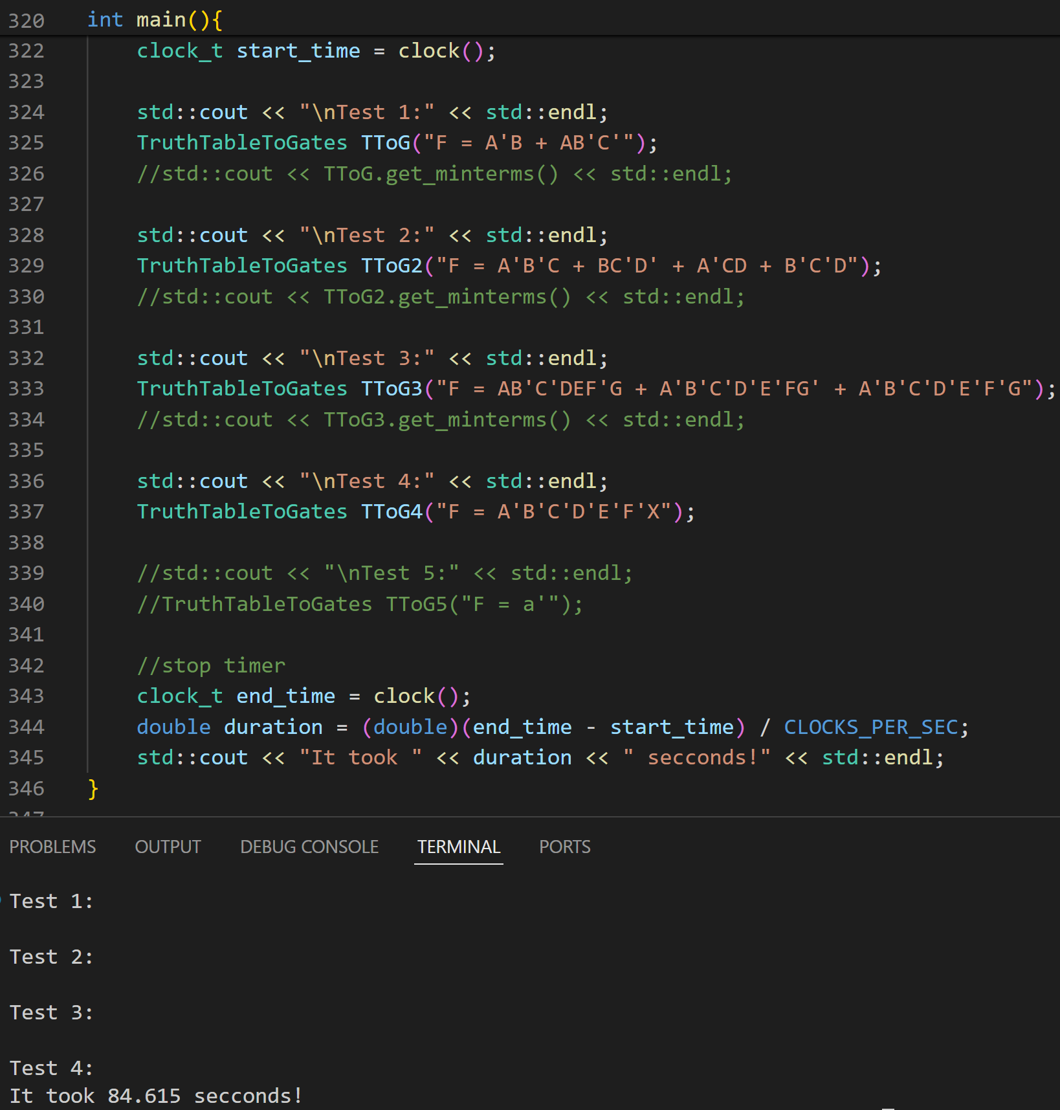

As you can see its not great, my current hypothesis for why the CPP version is slower is because of the inneficencies in the array archetecture I used. In python I used some built in functions to do what I wanted to happen, but in cpp I literally had to make my own class to interface with an array. Its literally a mess. Though I have two ovious way to speed up the CPP version! Num1, make the function that does all the calculations multithreaded! This might be easy, but honestly probbly not. Num2, make the list interfacing better. I don’t exactly know how to do this but if I can that would be awesome!

Think Aloud 5

Disclaimer, You should probably look into reading my older think aloud’s at the end of the document before reading the newest one 😉.

Remember last week how I needed to automate validating my logic gates via simulating them? Well that is what I did this week!

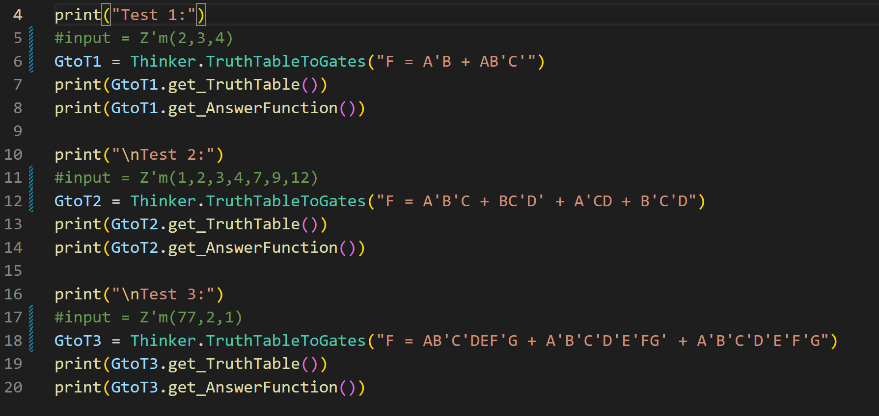

As you can see in this screen shot the commented lines are what I inputed into my other program to minimize the logic, the Function notation written in string format is what I received as an output. This program literally has one job, to return the same thing I put into the last program. (and also make and format me a truth table if I want it… but I havent implement that yet 😊). Here are the results of these three test cases:

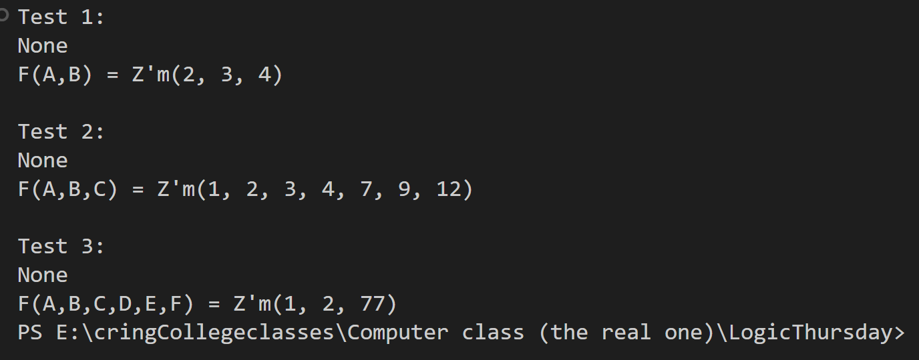

I love this so much better than my shitty program last semester, Both of these programs output their results within a few milliseconds where as my last attempt could take minuits to hours because I was brute forcing them. I am excited to have this done and next time I will be working on my GUI.

Think Aloud 4

Disclaimer, You should probably look into reading my older think aloud’s at the end of the document before reading the newest one 😉.

This week was amazing, I likely put over 30 hours into this project this week alone and have made more progress than all the week prior combined.

Getting straight to the point however I wrote over 1000 lines of code this week. Most of which were implementing the algorithm but many of them were in the CLI program.

Here is the CLI program in action:

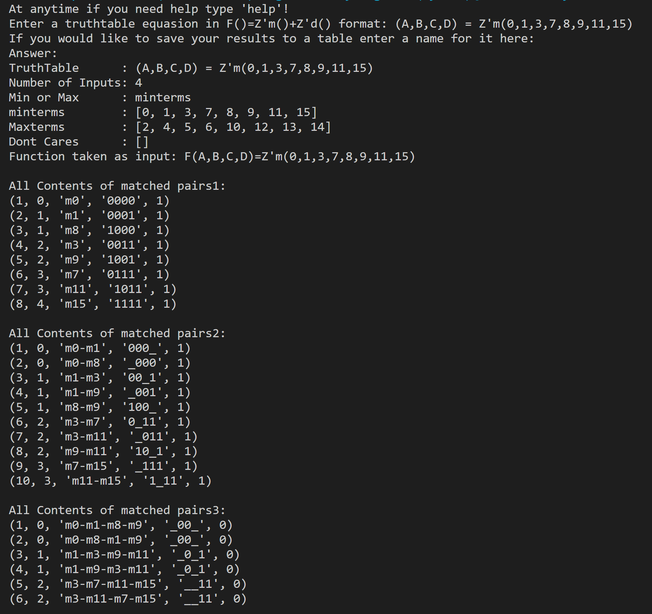

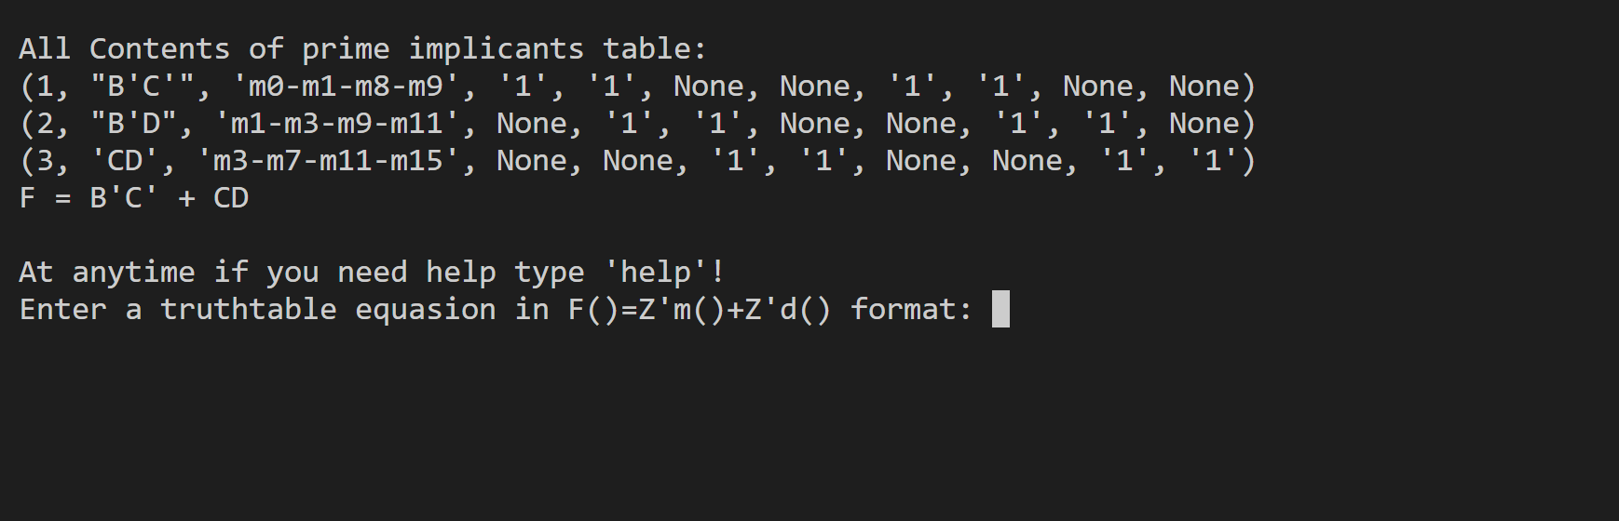

At the end you will knotice the “F = B’C + CD” this is the minimized form of the input function.

It is literally our answer, but still the program is only 1/3 the way to being fully functional. We cannot as of this moment solve for Maxterms or take In accout for Don’t Cares.

Here is a few test cases with the program as it stands:

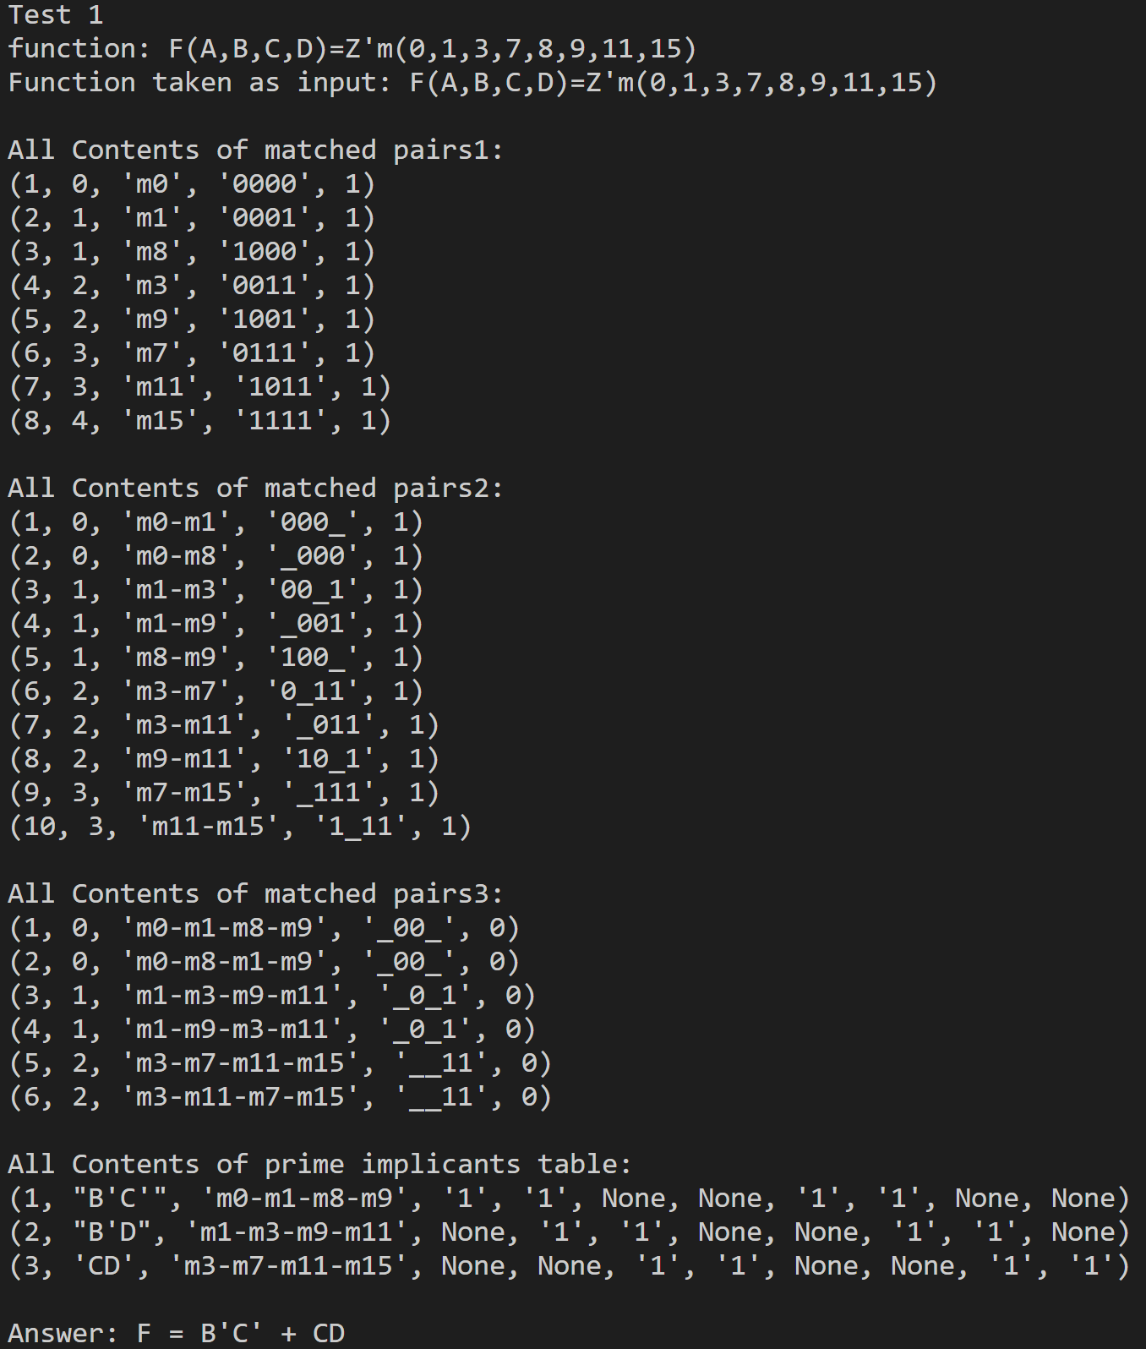

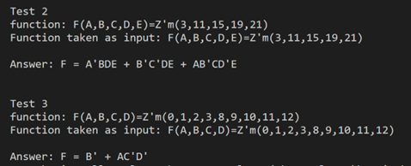

Words

The next logical thing to do however is not finish my program because how am I supposed to know if my outputs are even good? But the next step is to Test them, but rn I am way to lazy to actually program more so im going to build them in miencraft.

The input function “F(A,B,C,D)=Z'm(0,1,3,7,8,9,11,15)” this means there is four inputs, A, B, C, D. and when the inputs = the decimal numbers (0,1,3,7,8,9,11,15) we will get a high (1) output

Here is the miencraft equivelent to Test 1:

Minterm 0 – 0000:

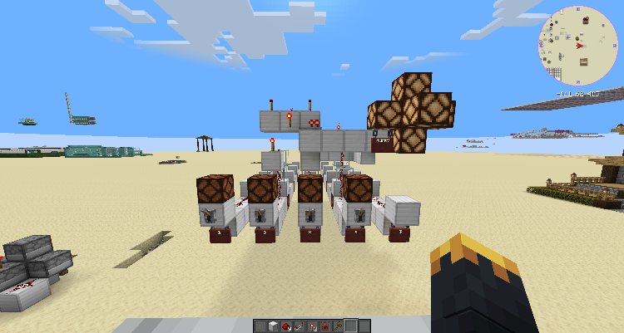

Minterm 1 – 0001:

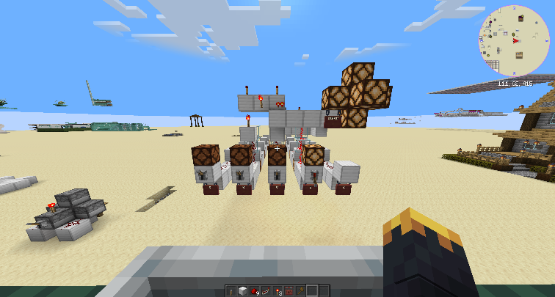

Minterm 2 – 0010:

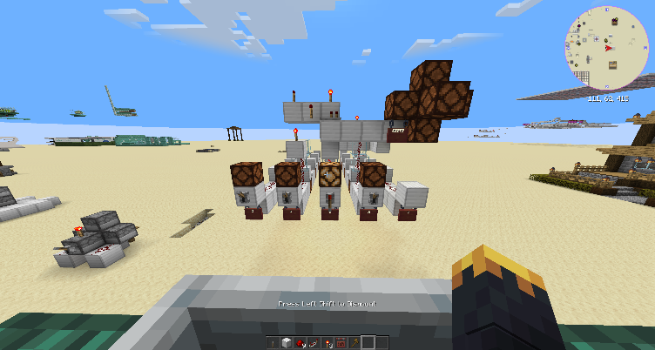

Minterm 3 – 0011:

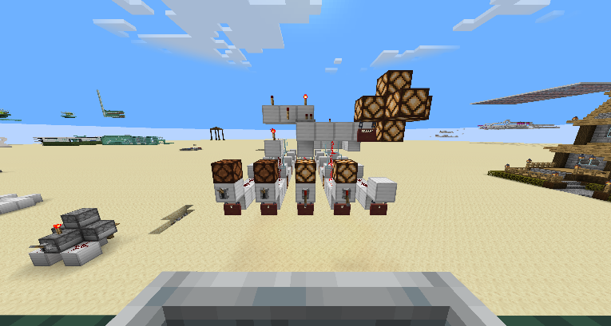

Minterm 4 – 0100:

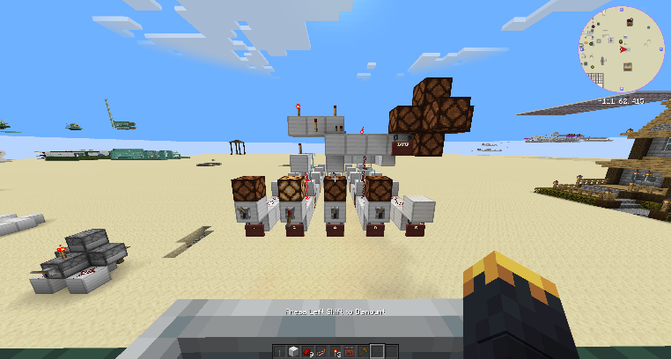

Minterm 5 – 0101:

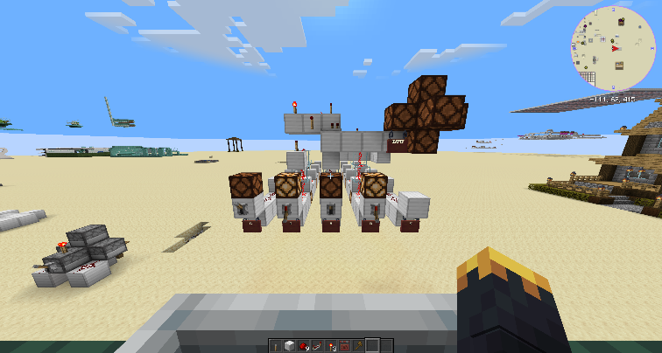

Minterm 6 – 0110:

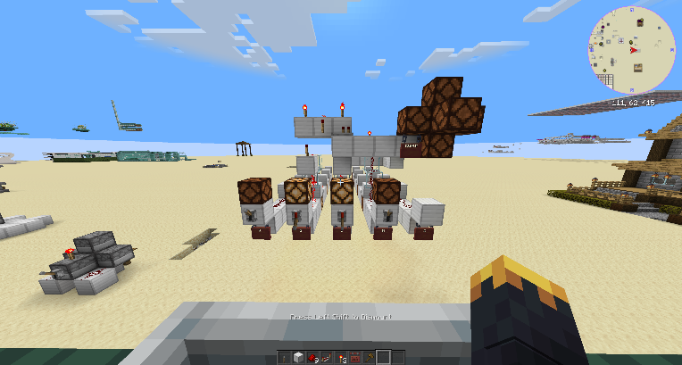

Minterm 7 – 0111:

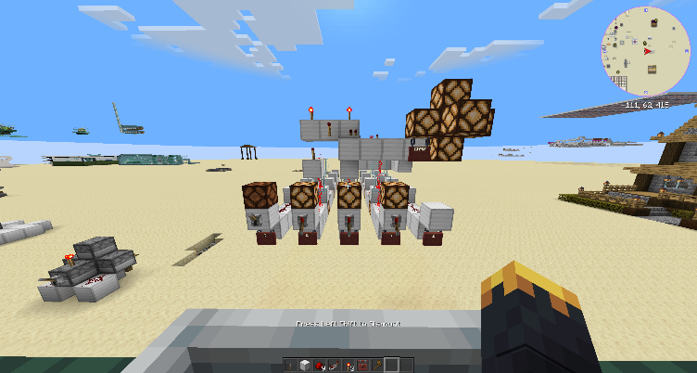

Minterm 8 – 1000:

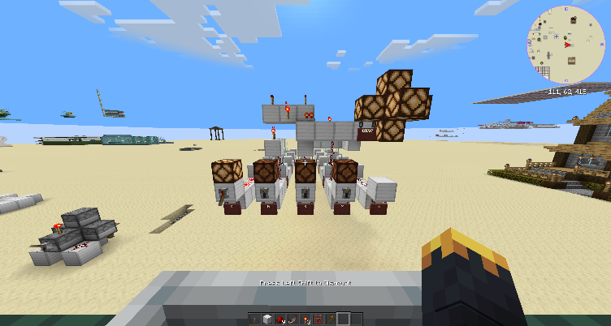

Minterm 9 – 1001:

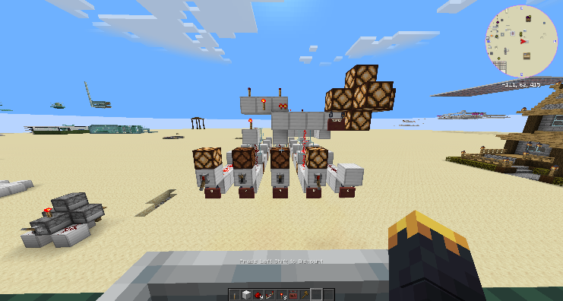

Minterm 10 – 1010:

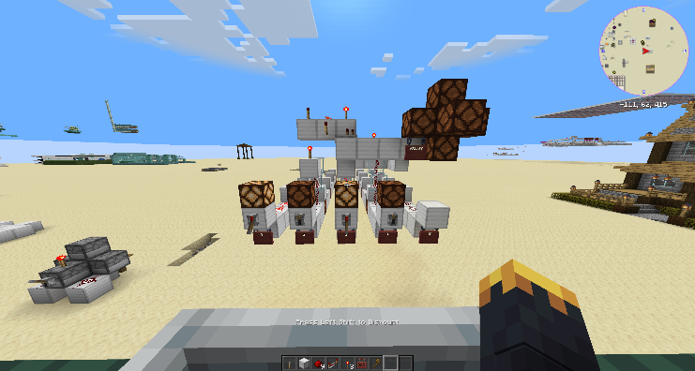

Minterm 11 – 1011:

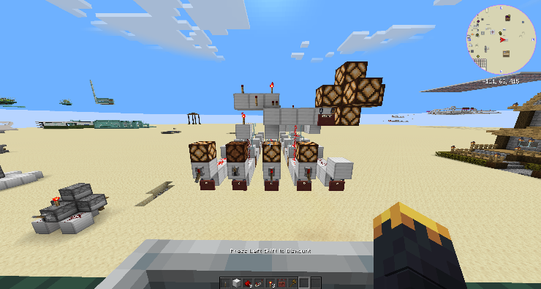

Minterm 12 – 1100:

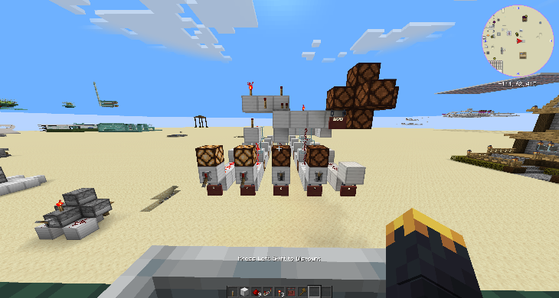

Minterm 13 – 1101:

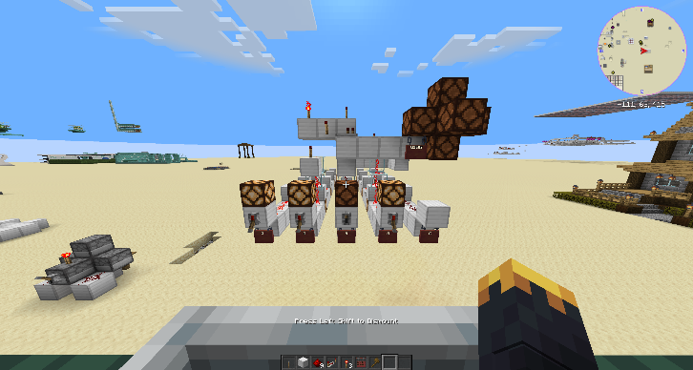

Minterm 14 – 1110:

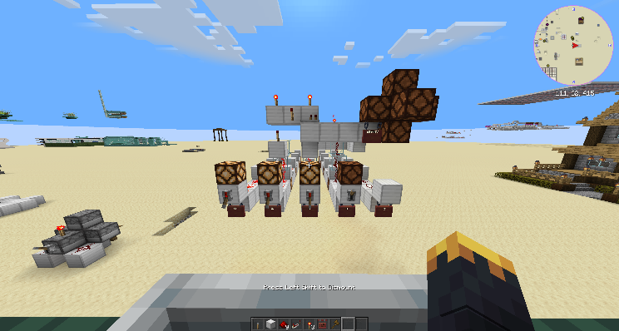

Minterm 15 – 1111:

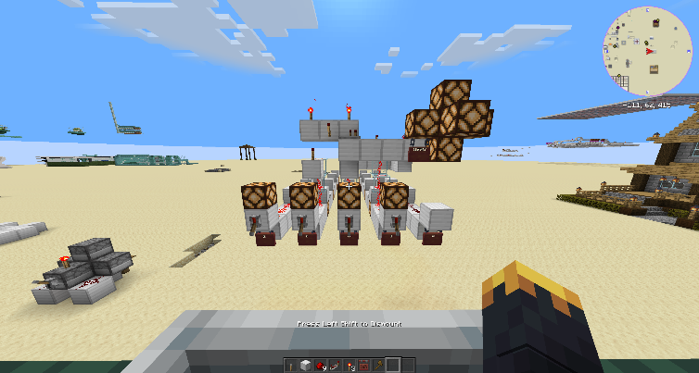

And so you see it does actually work, I did actually create a miencraft equivelent to the Test 2 test case but that would be 32 photos you would have to look at so I didn’t post them here, just know it does actually work.

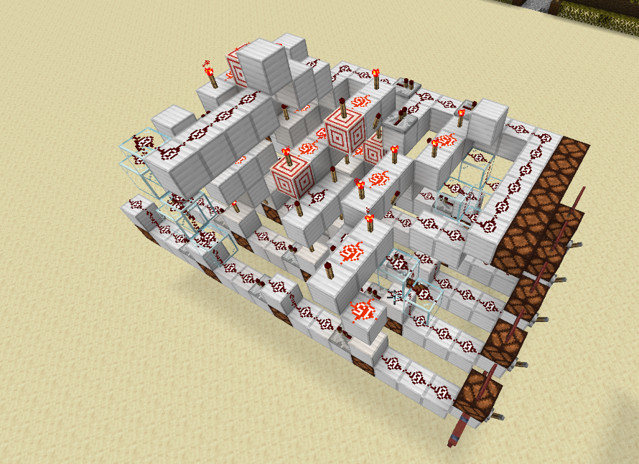

The next thing Im going to be working on is the LogicGates to TruthTable code. This will let me test the output of my code without having to physically build its analog inside of minecraft. I have only just started with this program’s code so it is nowhere close to being ready, though it is much simpliar to implement than the other program.

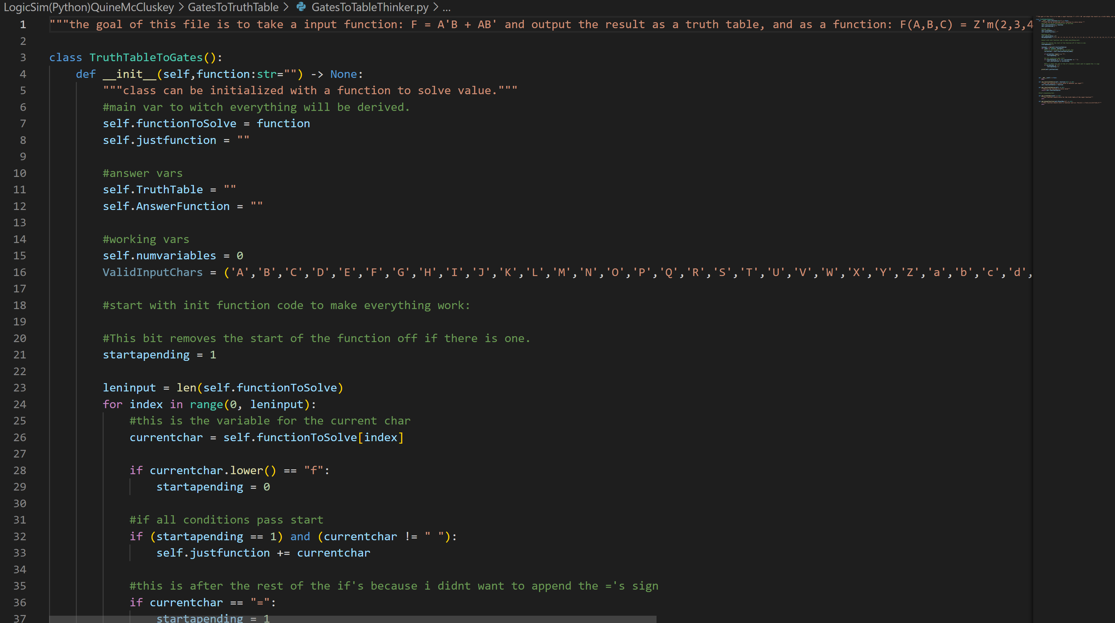

Anyway, Thanks for Reading! It means a lot to me

Think Aloud 3

Disclamer, All prior Think allouds are in order at the bottom of this document, I highly recommend you atleast skim them if you want the background for this new Think Aloud.

OK! So I did a lot of work on my project this week. The work can be summarized in two big steps.

1. I took another 7 pages of notes to finally understand what im doing.
2. I started implementing my project in Python using all the skills we learned last semester in Intro to CC.

Here is the notes I took, The summary is:

* I know what Implicants, Prime Implicants and Essential Prime Implicants are.
* I know how to calculate K’Maps using Don’t care.
* I know how to Calculate 4 Variable K’Maps
* I know how to Calculate a K’Map Using MaxTerms instead of minterms.
* I know how to Calculate 5 Variable K’Maps
* And finally, I know how to calculate the minimal form of a boolean equation using the “Quine-McCluskey” technique.

Here is a link to the playlist is made to teach me these consepts: <https://www.youtube.com/playlist?list=PLZI75QDLkI8-tFs5Ofs1-Ul1Gx10wunLM>

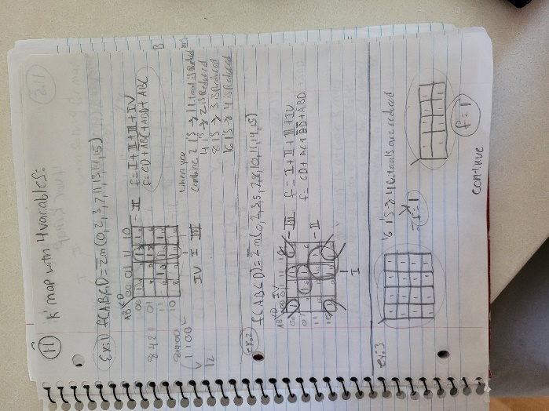Here are my notes if you want to look at them, though I doubt you can read them because I can’t either:

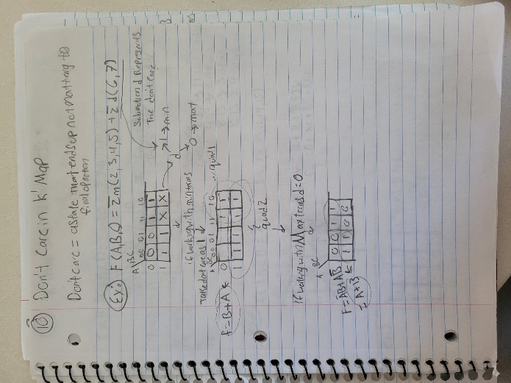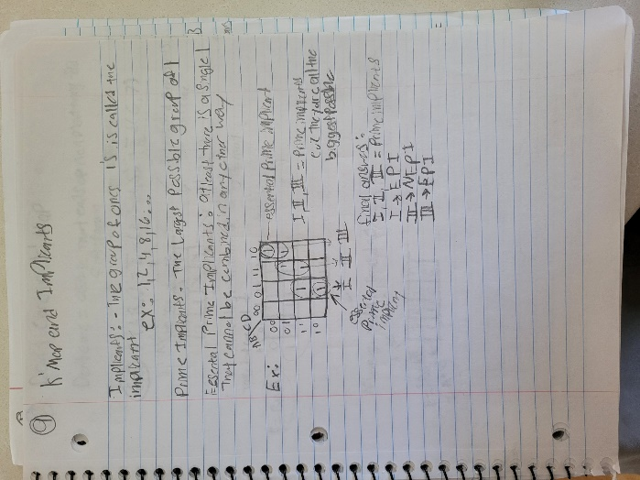

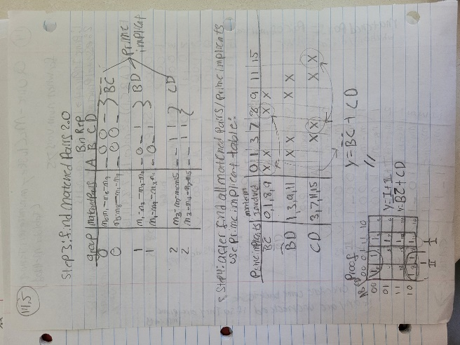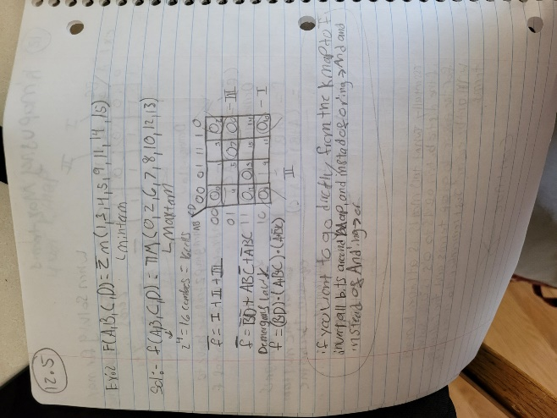Pt2:

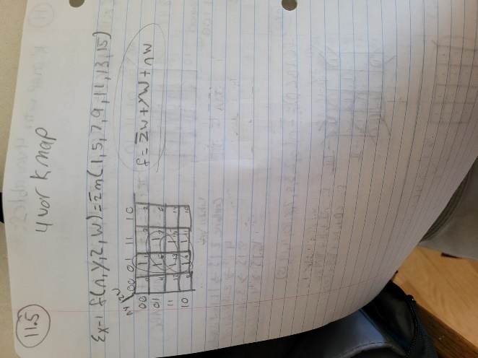

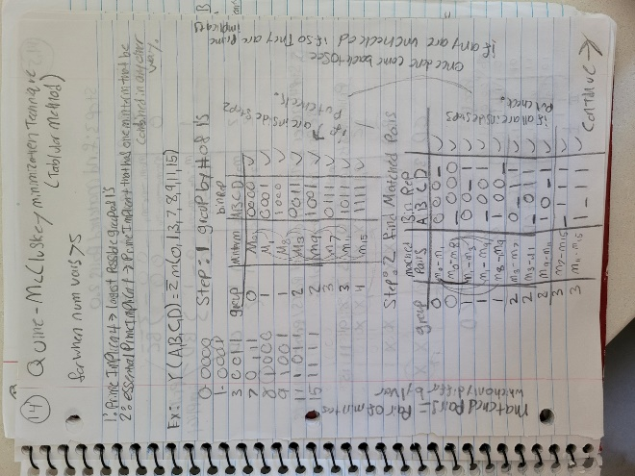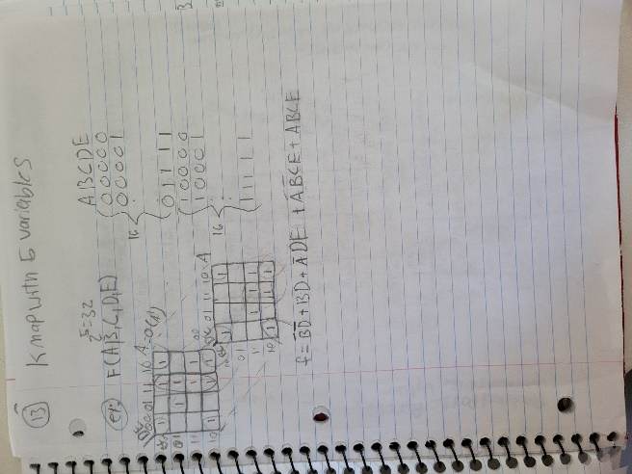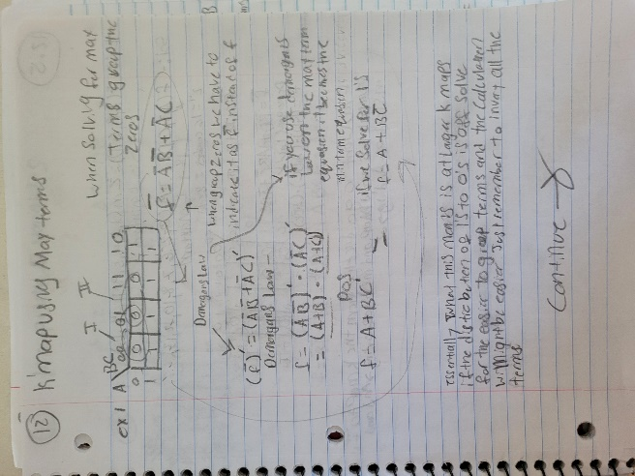Now the seccond part is a bit more interesting because I finally was able to actually start on the programming part of things. The first thing I did was split my LogicThursday Repo into two different folders, the old LogicSim(original) and the new LogicSim (QuineMcCluskey). Then I made a folder called TruthTable to Gates, and inside of that I made three python scrips called “CLITruthTableToGates.py”,”GUITruthTableToGates.py”,and”TruthTableToGatesThinker.py.” These are all self explanitory, but the CLI is the only place I have put any code for interfacing with Thinker at the moment, and Thinker has most of my time put into it. Inside of Thinker I have written around 200 Lines of text and Code describing What I need done, where, and how. I have made my Thinker object as close to done as possible without actually starting to write the algorithm.

At the moment this is what happens if I run the program from the CLITtoG:

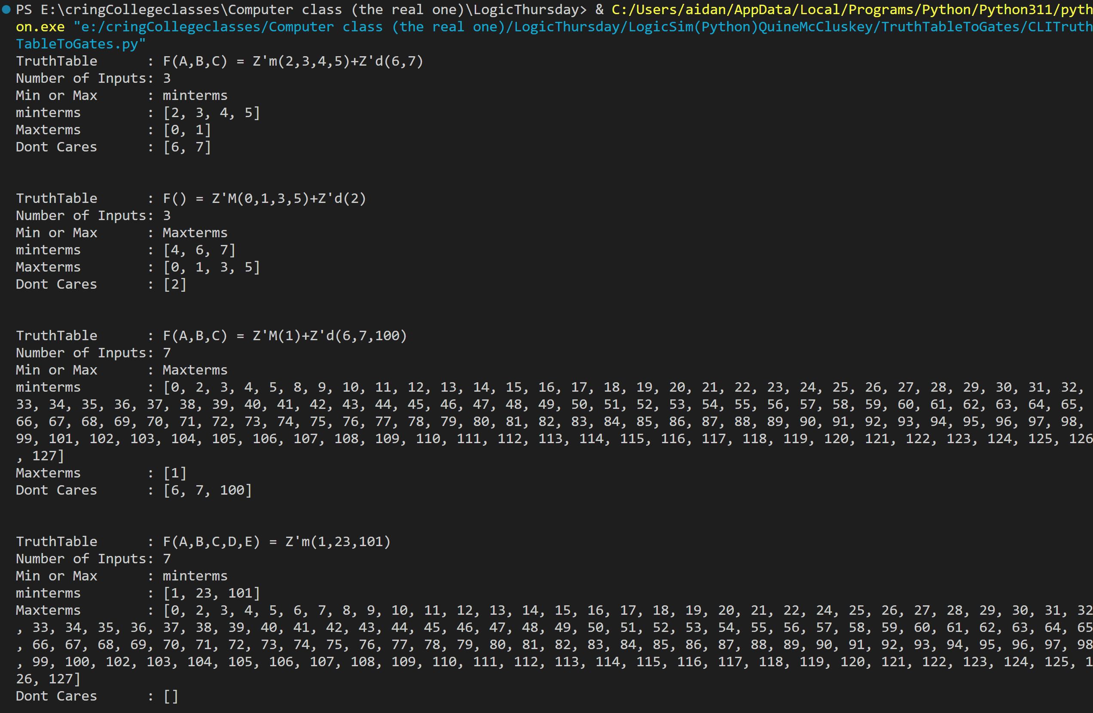

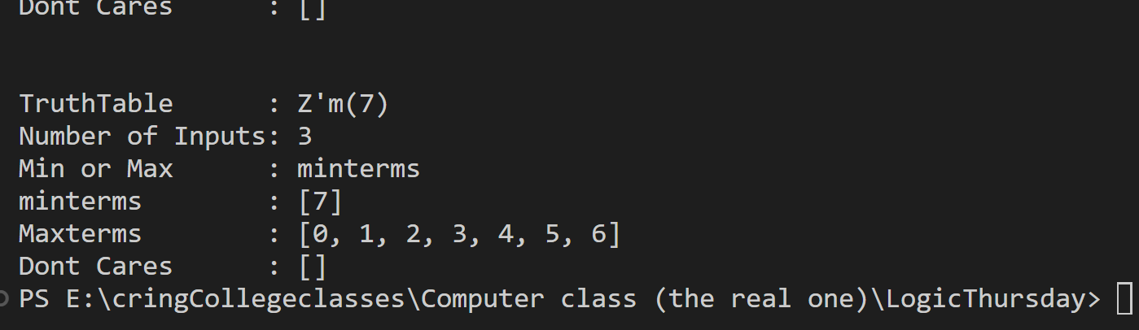

As you can see all I have done is make some test cases for my program so that I know I have the input and output of my program solved. I am using Getters to retrieve any information that I may need from my TruthTableToGates Object.

Im so glad I am finally getting to understand this project and what I need to do to make things work. But other than that, here is a link to my repo: <https://github.com/regtoga/LogicThursday> and I want you to have a nice day! I you want to find me I will be working on the next submission for my Think Alloud Week 8.

Think Aloud 2

This is Pt2, if your wondering whats happening here I will append my last Think Aloud to the bottom so if you want to catch up you can.

[Link To The Learning Resources i used to figure this stuff out.](https://youtube.com/playlist?list=PLZI75QDLkI8-tFs5Ofs1-Ul1Gx10wunLM&si=LpWYsQz3FHPoYmn0)

So since last time a lot has happened, but let me start out by saying, whatever it is im trying to solve its very complex. I have essentially started taking another class to understand this topic by itself. From what I have found my problem is defined as the “minimization of truthtables.” From my research there are three main ways to minimize a truthtable and its accompanying logic, they go inorder from:

1. boolean algebra
2. Karnaugh Map (K’ Map)
3. Quine-McCluskey Minimization Technique

These three methods are all equally valid except for different senarios.

Number one. Boolean Algebra is essentially using algebra but on boolean numbers and with a few odd rules. Think back to your math class when your teacher asked you to simplify an expression, well Boolean Algebra can be used like that.

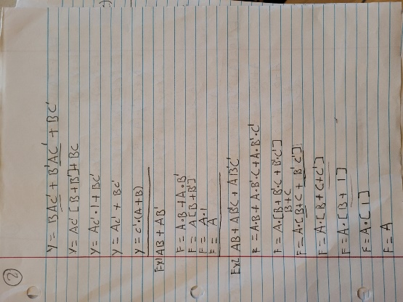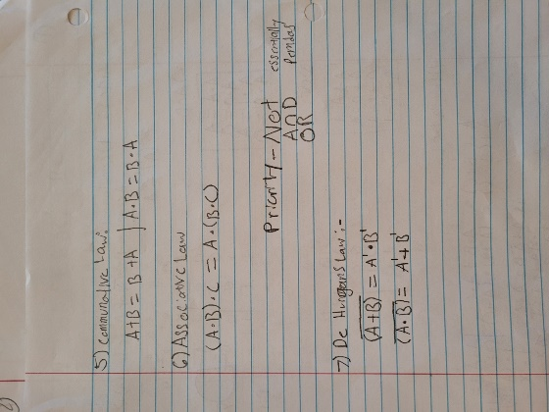Boolean Algebra notes:

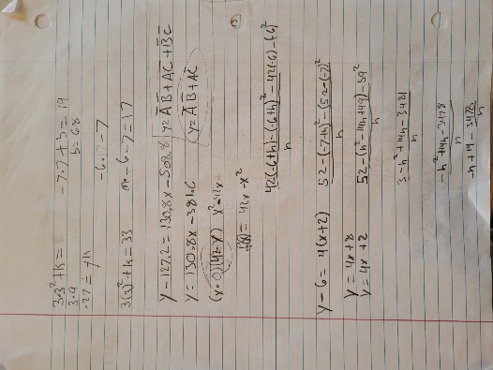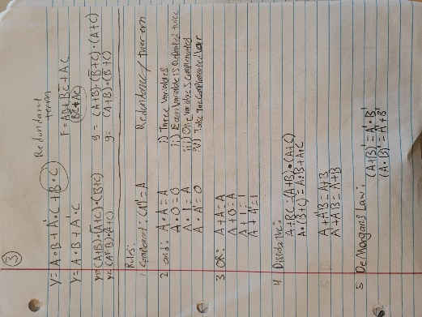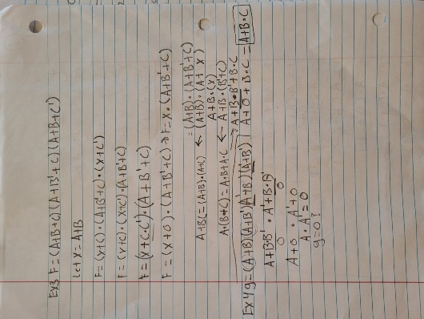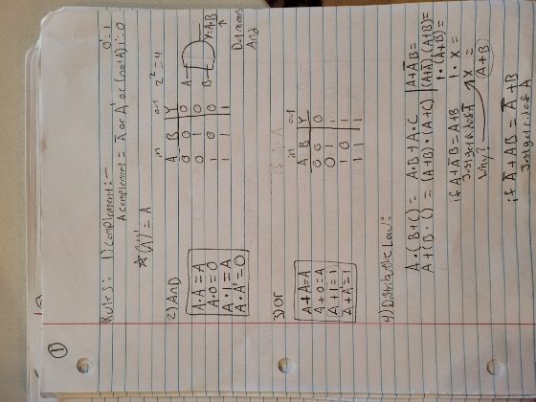

Number Two, Karnaugh Maps. K maps are essentially a way to organize your truthtable in such a way that if you look at it correctly the minimum SoP(Sum of Products) just pops out at you. Obiously it is more complicated than that, but I don’t feel like explaining it when I can just paste my notes into my word document. It is also important that Boolean Algebra and this step I needed to learn about SoPs and how to find them, what a minterm and Maxterm(‘s) are how to and what the minimal SoP form means/is. I also learnt that the most efficent way to store a truthtable is in this format F(INPUTS) = (Minterms that equled 1 here). It ends up looking like this: F(A,B,C)=Z`m(0,2,5,6,7). From this data I can construct a truth table that looks like this:

|  |  |  |  |
| --- | --- | --- | --- |
| A | B | C | F |
| 0 | 0 | 0 | 1(m0) |
| 0 | 0 | 1 | 0 |
| 0 | 1 | 0 | 1(m2) |
| 0 | 1 | 1 | 0 |
| 1 | 0 | 0 | 0 |
| 1 | 0 | 1 | 1(m5) |
| 1 | 1 | 0 | 1(m6) |
| 1 | 1 | 1 | 1(m7) |

AnyWay here is my Notes:

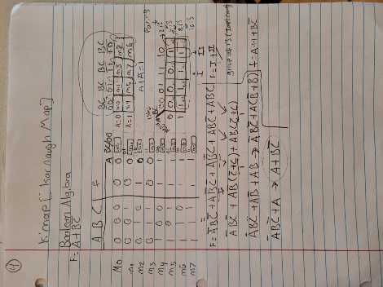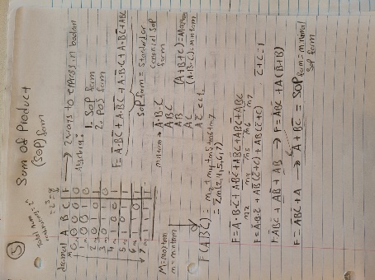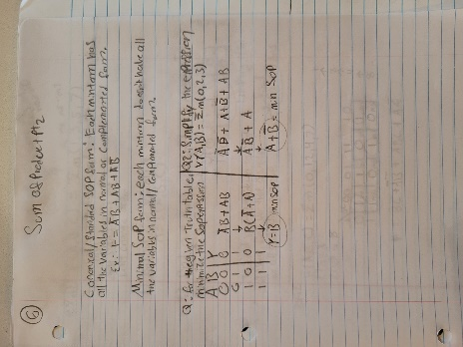

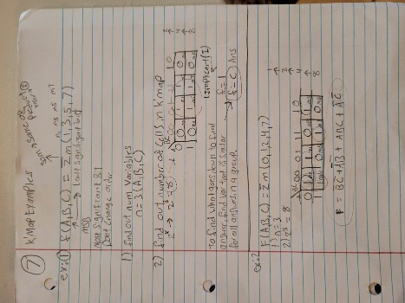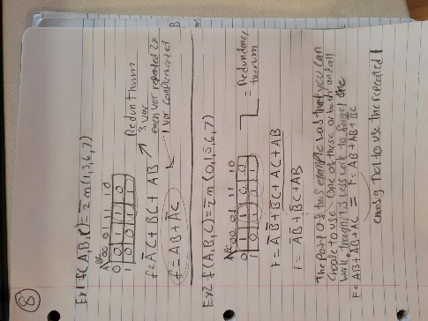

Now, I did not have time this week to get to the Third minimization technique, or enough time to implement any of these techniques, but I want to thank anyone who made it this far in my rant, Thanks! I hope to have more tangable progress next week.

Think Aloud 1

For my Think Alouds this semester I want to do one of three things building from last semester’s think-alouds.

First some context on my project, “Logic Thursday” at this moment is MY creation, I have had ZERO help creating it. This is important because up to this point, I have only used my background knowledge and my first most obvious algorithm to solve the issue. This being said from this point on I will be using Google and possibly chat-GPT to find ways to improve my program. I have rules for myself still though, I CANNOT copy and paste code from GPT into my project and I have to understand the algorithms I may want to implement into my code. The purpose of this activity has always been for me to see exactly how far I can take something that I want to make, not how many ideas can I steal from other people.

The three things are:

1. Find an algorithm, whether it be related to ["Circuit Complexity"](https://en.wikipedia.org/wiki/Circuit_complexity) or optimizing my current brute force method to hasten the time taken to calculate a good/decent solution to a problem.
2. (This depends on number 1) Port my “Logic Thursday” code to CPP directly and test the speed increase!

SubGoals:

* 1. Make my CPP Logic Thursday Multithreaded! (i want my program as fast as possible)

1. (This depends on number 2) This slightly deviates from the others I have listed, but I would like however possible create a GUI to connect Logic gates visually and or render visually already created logic gate arrays. This would likely be easiest in Unity, but I want to keep it in CPP so I might use Unreal. This gives the added benefit of providing me with built-in Lumin and Nanite support, making it possible to make each gate possibly consist of thousands of polygons all while utilizing global illumination to light the scene. (sorry, this is today's version of humor)

Anyway, I plan to get working on this asap, and thanks for reading!